Week 4 Day 1 Participation Screen Shots

Hector Cardona Alvarez
College of Business, Westcliff University
WEB 601 Front-End Web Development
Week 4 – Day 1
Professor Dr. Wissam Ahmed
July 20, 2026

Challenge 1
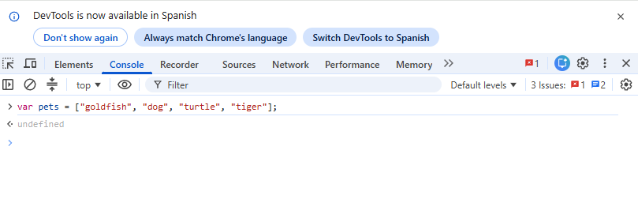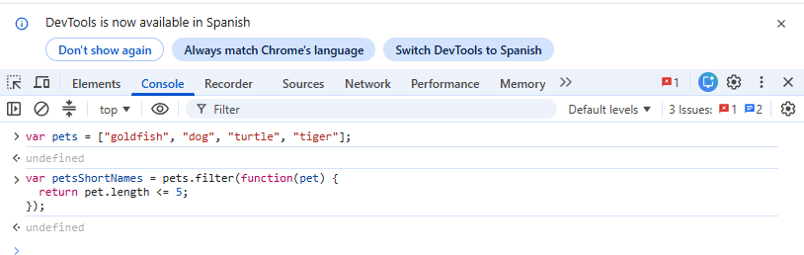

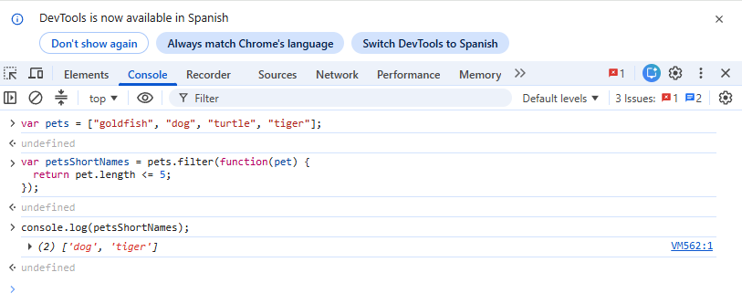

Challenge 2
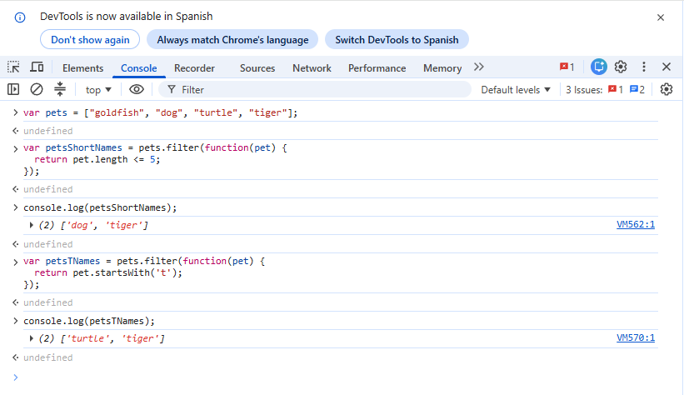

Challenge 3
